MS DAILY BRIEF - 18 October 2022

Coupons
Steadfast Noon | NATO has begun conducting nuclear deterrence exercises 1
New deployments of military technique without official military insignia have been observed in Belarus (Photo/Video). Russians changed the letter Z to a stylized triangle 2
Iran prepares Fateh-110 and Zolfaghar ballistic missiles for Russia, forcing Israel to pave the way for historic aid to Ukraine 4
A casualty barometer: Russia pulls technically worn-out MiG-29s out of storage to drop them into combat in Ukraine 5
Most Soviet military equipment was taken out of "mothballs" for the Ground Forces, including the old T-62. 6
The explosion of the Kerch bridge has upset Moscow's plans, forcing it to use the Mariupol route. "75% of the supplies were passing through there" 7
Ukraine has asked the US for Cold War-era Hawk air defence systems. Advantages and disadvantages of the Hawk 8
"Short, sharp, hard landing" for container transport 10
Two Russian corvettes arrive in the Mediterranean, where the US aircraft carrier George H.W. Bush leads a NATO show of force 11
Russia has increased the volume of maritime container traffic in the Caspian Sea fivefold in three months 11
Novorossiysk. Russia plans to create "shipbuilding infrastructure" 12
"Nibulon" has completed the first stage of construction of a new grain terminal on the Danube 12
A bulk carrier on his way to Odessa for grain had an accident near Istanbul 13
Change at the helm of the Fleet 14

Steadfast Noon | NATO has begun conducting nuclear deterrence exercises

https://youtu.be/TQmabVAkX_w

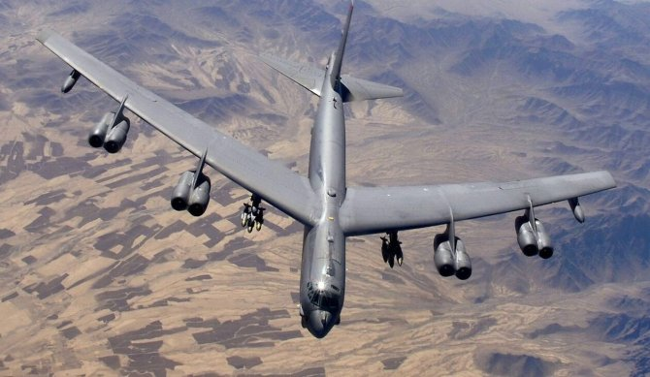

Armed forces from 14 NATO member countries began their annual exercise to simulate the defence of North Atlantic Alliance territory using nuclear weapons on Monday, DPA reports.
The exercise, dubbed 'Steadfast Noon', involves nearly 60 aircraft, including fighter, surveillance and refuelling aircraft, as well as US B-52 long-range bombers, which will fly from

North Dakota, according to NATO. The training flights will take place over Belgium, which is hosting the exercise, as well as over the North Sea and Britain, NATO said, stressing that no real weapons will be used. The 'Steadfast Noon' exercise "is routine, recurrent training and is not linked to any current world event," a North Atlantic Alliance press release said. The exercise is hosted by another NATO state every year, spokeswoman Oana Lungescu said. "This exercise helps to ensure the safety and effectiveness of the Alliance's nuclear deterrent capability," she said.
Under NATO's joint nuclear programme, US nuclear weapons stationed in Europe can also be used by partner states' aircraft in an emergency to combat enemy forces, for example. US nuclear weapons are stored in Belgium, Turkey, the Netherlands and Germany, according to information not officially confirmed by the alliance.

https://www.defenseromania.ro/nato-si-a-inceput-exercitiul-nuclear-anual_618860.html

New deployments of military technique without official military insignia have been observed in Belarus (Photo/Video). Russians changed the letter Z to a stylized triangle

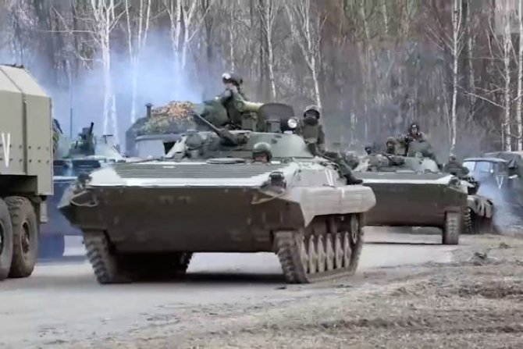

New trains loaded with military equipment, including 2C5 Giatsint-S self-propelled artillery systems and 1B13 and 1B14 command vehicles, which make up the artillery battery, were seen in Belarus. However, the most important point to note is not related to troop movements on the territory of Belarus, but to the fact that all the military equipment does not have official military markings - a new tactical sign in the shape of a triangle has been stylised on them.
In one of the videos on social media, this sign is seen on most vehicles, including trucks and even a tractor. Ukrainian media reports that the train carrying the military equipment belongs to Belarus, not Russia. The quoted source notes that when Russian troops are deployed in Belarus, wagons belonging to Russian railways are used. When about the application of a new ''tactical insignia'' on military equipment, the Ukrainian publication DefenseExpress recalls that this has become commonplace for the Russians and recalls the early days of the Russian invasion when large units of Russian troops had insignia in the form of the letters Z, V, O stylised on military vehicles. The newly formed Russian 3rd Army Corps had at the beginning of the military aggression in Ukraine a tactical sign in the form of an inverted triangle with a circle, but this was found on a small number of military vehicles. At the same time, a so-called more detailed presentation of this new tactical insignia, which would actually mark the military equipment spotted by Russia in Belarus, appeared on Telegram channels on which the Russian military communicates.
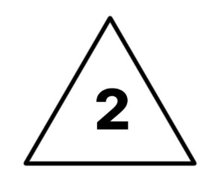

If the information is correct, there should be a "two" in the middle of the triangle. The symbolism of this mark, such as "second front" or "second attempt", is omitted. At the same time, according to the official statement of the Ukrainian Ministry of Defence, a large number of Russian troops have already started arriving in Belarus. In the official video recordings, published by the Russians, no tactical markings are seen on military equipment. But in another video, which appeared on social media, showing the deployment of other artillery units of the Belarusian army have similar tactical markings. It should be noted that this deployment of troops was observed about 5 km from the border with Ukraine.It should be noted that yesterday, October 16, in Minsk were observed several MiG-31 aircraft, which may be carrying missiles "Kinzhal".
https://www.defenseromania.ro/belarus-trimite-in-rusia-tehnica-militara-fara-insemne-oficiala-foto-video_618857.html

Iran prepares Fateh-110 and Zolfaghar ballistic missiles for Russia, forcing Israel to pave the way for historic aid to Ukraine

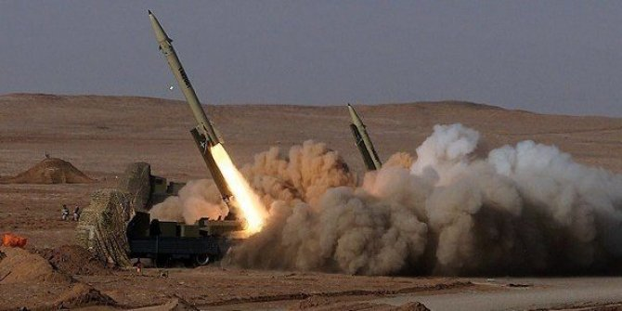

Israeli Minister of Diaspora Affairs Nachman Shai has supported his country's military aid to Ukraine. The change of heart by Israeli officials was prompted by growing signs that Iran is stepping up military aid to the Russian Federation, with Minister Nachman Shai suggesting in a Twitter post on Sunday that Israel should provide military equipment to Ukraine. "This morning (October 16, editor's note) information emerged that Iran is transferring ballistic missiles to Russia. There is no longer any doubt about Israel's position in this bloody conflict.
It is time for Ukraine to receive military aid, as the United States and NATO countries are already providing," the Israeli official said. Israeli arms deliveries to Ukraine will "destroy" the Russia-Israel relationship. Former Russian president and current number two in Russia's Security Council, Dmitry Medvedev, reacted and warned Israel that arms deliveries to Ukraine will "destroy" relations with Russia, reports Agerpres.
"Israel seems to be preparing to deliver weapons to the Kiev regime. This is a very unwise step. It will destroy all interstate relations between our countries," the deputy chairman of the Russian Security Council said on his Telegram account. If such a decision is indeed taken, Israel would have "reason to declare Bandera and Shuhevich its heroes," he added, quoted by the pro-government news portal life.ru.
Medvedev was referring to the controversial Stepan Bandera and Roman-Taras Shuhevich, seen by some Ukrainians as heroes who fought for independence and by others as anti-Semitic war criminals involved in the murder of up to 100,000 Jews and Poles during World War II.

Iran prepares to send ballistic missiles to Russia
On 16 October, The Washington Post, citing US and allied security officials, reported that Iran is stepping up its commitment to supply Russia with weapons for the war against Ukraine. Tehran is ready to transfer not only drones but also ballistic missiles.
According to US officials, Tehran sent officials to Russia on 18 September to finalise the terms of additional arms deliveries, including two types of Iranian surface-to-surface missiles. An intelligence assessment shared with Ukrainian and US officials in recent days claims that the Iranian arms industry is preparing the first batch of Fateh-110 and Zolfaghar missiles, two of Iran's well-known short-range ballistic missiles capable of hitting targets at ranges of 300 and 700 kilometres respectively. If this happens, it will be the first delivery of such missiles to Russia since the start of the war. In August, the same officials identified two types of Iranian drones, Mohajer-6 and Shahed-136, which Tehran had begun to supply to Russia for use in Ukraine.In addition, the Russians have begun to use a new type of Iranian kamikaze drone in Ukraine: the Shahed-131. Fragments of a drone of this type were found for the first time on Thursday 13 October in the Kiev Region.
https://www.defenseromania.ro/iranul-pregateste-rachete-balistice-fateh-110-si-zolfaghar-pentru-rusia-israelul-raspunde-printr-un-ajutor-militar-istoric-pentru-ucraina_618844.html

A casualty barometer: Russia pulls technically worn-out MiG-29s out of storage to drop them into combat in Ukraine

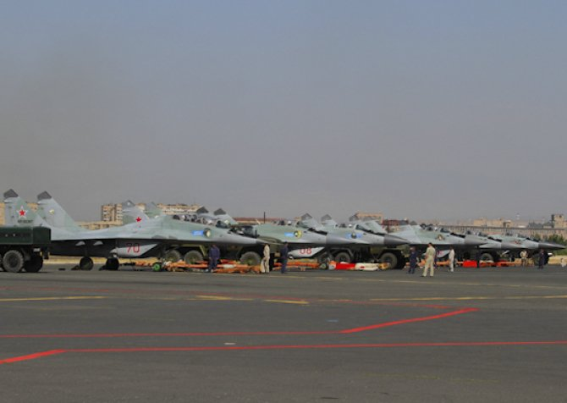
Russian MiG-29 aircraft, photo: Ministry of Defence of the Russian Federation

The Russian Federation is removing from storage several MiG-29s "forgotten" in military bases due to technical and moral degradation. According to Mil.in.ua, which has published satellite images of Russian military bases, reports that on 15 October 2022 the Russian Federation removed from storage and reactivated several MiG-29 aircraft at a military base in the city of Millerovo.
According to the source, these planes had been at the Millerovo Air Base, Rostov region, for a long period of time, during which time they had not been operated. After all, the air base in question had not been operational since 2009, until 2014. According to official data provided by the International Institute for Strategic Studies (IISS), in 2021 the Russian Federation will have 87 MiG-29 aircraft in various versions active. The aircraft are under the command of the Russian Air Force and Russian Naval Aviation.
Russia is aiming to replace the MiG-29 with the Su-35, but it seems that the losses in Ukraine have thrown a bit of a wrench into Russian plans, and the MiG-29 has been reactivated in some regions. MiG-29 fighter jets in the SMT version, which have not been operated for years, have been taken out of storage and reactivated in the Kursk region as well. This version was developed by the Russians in 1997.
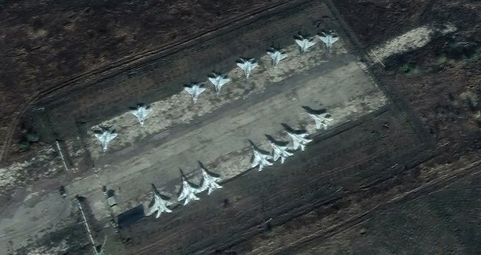
MiG-29SMT aircraft, taken out of storage at an air base in Kursk, Russia. Satellite image via Mil.in.ua

Most Soviet military equipment was taken out of "mothballs" for the Ground Forces, including the old T-62.
However, the bulk of the military equipment lost during the almost 8 months of war belonged to the Ground Forces, which is why the Russians had to resort to the stocks of Soviet equipment.Since May this year, as a result of the lost military equipment, the Russian Federation has "taken out of mothballs" the old Soviet T-62M tanks and transferred them to the Ukrainian front. These tanks are on average about 50 years old, and the age of the military who know how to operate them at their most efficient capacity must be at least 60. The T-62 tanks do not have a laser rangefinder or a functioning fire control system. That's why those who now operate these tanks are hastily retrained mechanic-drivers from the T-72 and T-64 tanks.
It is estimated that Russia currently has around 300 T-62M units that it has upgraded.
https://www.defenseromania.ro/un-barometru-al-pierderilor-rusia-scoate-din-depozite-avioane-mig-29-uzate-tehnic-pentru-a-le-arunca-in-lupta-in-ucraina_618854.html

The explosion of the Kerch bridge has upset Moscow's plans, forcing it to use the Mariupol route. "75% of the supplies were passing through there"

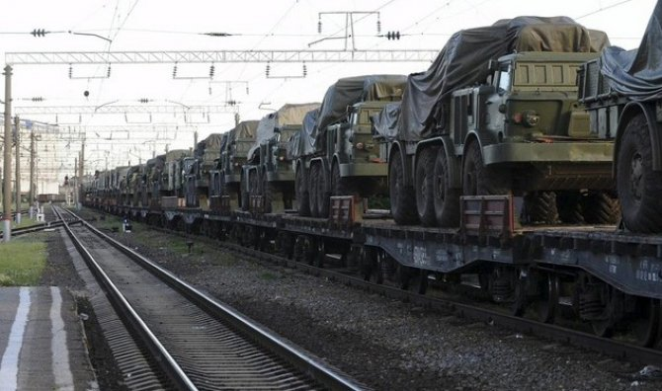

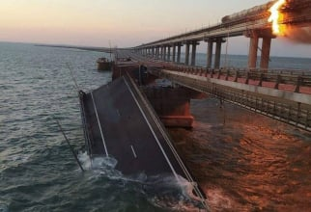
As a result of the damaged Crimean bridge, the Russian occupation forces are unable to transfer weapons and equipment from Crimea.
The logistical problems faced by Russian forces in southern Ukraine have worsened after the bridge over the Kerch Strait, which connects the Crimean peninsula (illegally annexed by Moscow in 2014) to Russian territory, was damaged on 8 October. The bridge played a key role in supplying equipment, British intelligence said on Monday in an update on the situation on the Ukrainian front, according to Agerpres, citing Reuters.
"Under tense conditions for the Russian presence in Herson, amid deteriorating supply lines through Crimea, the land line through the Zaporozhye region (south) is becoming increasingly important for the sustainability of the Russian occupation," the UK Ministry of Defence says in a regular Twitter bulletin.
Russian forces in southern Ukraine are reportedly stepping up their logistical supply flow through Mariupol, a port city on the Sea of Azov, in an attempt to compensate for the reduced carrying capacity of the partially damaged bridge, the update said.
Ukrainian authorities confirm the difficult situation in which the Russian Federation finds itself: "They are in a very critical situation with equipment, with supplies, with logistics. Almost 75% of these supplies were passing through the Crimean Bridge. Even the sea is on our side (...), because they even stopped the ferries. Because of the wind, it's impossible to make connections between the points across the strait, so they are really suffering because of the lack of equipment, ammunition and military equipment," said Natalia Humenyuk, press officer of the Ukrainian forces' Operational Command "South", quoted by Ukrinform.
On the morning of 8 October, there was a powerful explosion on the Kerch bridge and a train with fuel tank cars blew up. Russia had previously said that the bridge, a project dear to President Vladimir Putin, was well guarded by Russian air defence systems and military personnel, stressing the reliability of the infrastructure, according to international news agencies. Moscow has blamed Ukrainian special services for the explosion on the Kerch bridge and has responded with intense missile strikes across Ukraine, including Kiev, hitting energy infrastructure and civilian targets in particular. Repairs to the Crimean bridge will be completed in July 2023. The Russian authorities want to complete work on the Crimean Bridge, damaged by the 8 October explosion, by 1 July 2023, reports RadioSvoboda.
Earlier, Russian officials said the repair could be completed in a month and a half, but the latest figures show it will take 8.5 months.
https://www.defenseromania.ro/explozia-podului-kerci-a-dat-peste-cap-planurile-moscovei-fortata-acum-sa-foloseasca-ruta-mariupol-75prc-din-provizii-treceau-pe-acolo_618855.

Ukraine has asked the US for Cold War-era Hawk air defence systems. Advantages and disadvantages of the Hawk

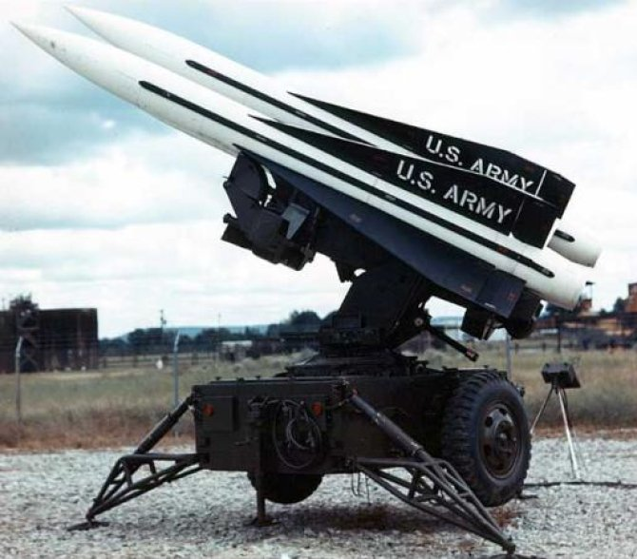
MIM-23 Hawk system, photo: U.S. Army

Kiev requested MIM-23 Hawk air defence systems at the Ramstein-6 meeting.
The Hawk system was put into service in 1960 and has been the main NATO air defence system since the Cold War era. After 1990 it was replaced by more modern weaponry, notably the Patriot system, but is still used by other militaries considered among the most powerful in the world. The Ukrainian request for the MIM-23 Hawk was announced by US defence secretary Lloyd Austin during a press briefing after the Ramstein-6 meeting.
Kiev's calculation for equipping its forces with Hawk systems seems, to say the least, a particularly pragmatic and inspired one, given the large number of assets that have been manufactured over the years.
In addition, the system has undergone four major upgrades, the last of which took place in the 1990s, just before the US began decommissioning it. At that time the complex was digitised with the ability to intercept multiple targets simultaneously and destroy them at low altitude. Thanks to computerisation, it was possible to upgrade the system continuously, resulting in the Hawk XXI variant, which is now in the service of the Turkish armed forces. Modern radar for MIM-23 Hawk systems. The main feature of the latest MIM-23 Hawk version is the integration of the modern AN/MPQ-64 Sentinel radar, which is also used in the NASAMS air defence system. Meanwhile, the complex's firepower continued to rely on the MIM-23 anti-aircraft missile, which was constantly updated and upgraded until the mid-1990s. It can hit targets up to a range of 45-50 km and a height of 20 km. The missile is guided to the target by a semi-active homing head and reaches a maximum speed of Mach 2.4. But the most important advantage is that more than 40,000 of these missiles have been produced, and in the foreseeable future there is likely to be no difficulty in supply.
Disadvantages: Need to deconserve and rebuild missiles
There are, of course, drawbacks, including the need to deconserve and refurbish missiles, and in older versions there are a large number of radars in the system. For example, the 1970s version of the Improved Hawk includes: target illumination radar AN/MPQ-46, targeting radar AN/MPQ-50, radar range finder AN/MPQ-51, low altitude target detection radar AN/MPQ-48, information processing and command post AN/TSW-8, forward radar AN/MPQ-48, control post AN/MSW-11 and after three M192 launchers with three anti-aircraft missiles each. In comparison, the Hawk XXI version consists of: one command post, one AN/MPQ-64 Sentinel observation radar, one AN/MPQ-62 'low altitude' radar, one or two AN/MPQ-61 illumination radars and several launchers. The number of targets, which can be engaged at the same time, depends on the number of illumination radars.According to the Ukrainian publication Defense Express, the MIM-23 Hawk can cope very well in intercepting targets such as cruise missiles and kamikaze drones, but is not recommended to operate as an advanced air defence system deployed in the frontline.
https://www.defenseromania.ro/nato-va-livra-ucrainei-sisteme-anti-uav-pentru-bruiajul-dronelor-iraniene-folosite-tot-mai-intens-de-rusia_618853.html

"Short, sharp, hard landing" for container transport

MARITIME Strategies International (MSI), said in a recent podcast episode that the container sector is heading for a short, sharp and hard landing as the supply chain normalises and new ships come into service. From all-time highs a year ago, container spot rates have fallen 10% per week in the past month as the traditional peak season has not materialized.
"I think this collapse from astronomical highs is coming, it was only a matter of time," says Mr Kent, MSI's managing director, to the Seatrade Maritime Podcast.
While the end of the ultra-high-end market was always expected, the speed with which it came was a surprise.
"The problem we have in the container ship sector is that we've lost the demand side, which has never been that big, but rather the inefficiencies that have driven the container market up," he says.
Events such as the closure of major ports in China and the blockage of the Suez Canal by Ever Given in 2021 have contributed to the sharp rise in rates, however, the market has increasingly learned to cope with issues such as port closures. At the same time, the sector now faces the prospect of a newbuilding orderbook at 30% of the current fleet, with a large number of new deliveries starting to come on stream.
"Those ships are going to come in and take them fast over the next 24 months, which again will put downward pressure on the markets." Compared to the bulk cargo supercycle of 2004-2008, which ended abruptly with the global financial crisis and a hard landing that lasted about four years, Mr Kent sees a relatively short landing for container shipping. "So when I say hard landing, I think it would be a fairly short, sharp, hard landing." What will the hard landing look like?
"We've seen earnings drop 20% in two weeks and they could continue to drop that fast. So we could see earnings level off in about six to eight months. But overall, I think we're probably in for a period of low earnings in the container ship market for a two-year period."
Source: http://sisi.gstta.org/index.php?c=article&id=21817

Two Russian corvettes arrive in the Mediterranean, where the US aircraft carrier George H.W. Bush leads a NATO show of force

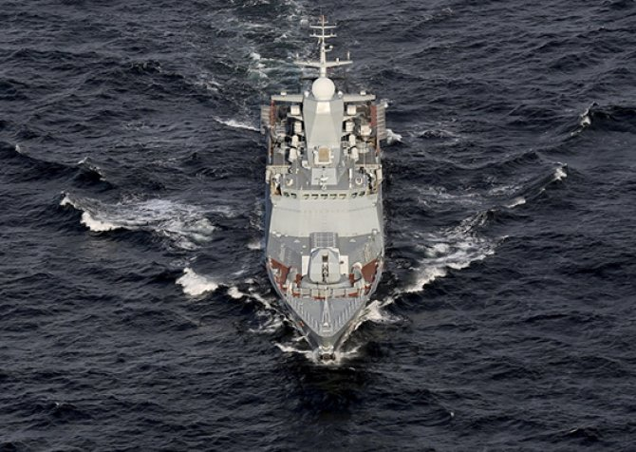
Navigation monitoring sources on Twitter and Telegram accounts reported that on the evening of 16.10.2022, new Russian warships entered the Mediterranean Sea.
These are the corvettes Stoikiy (545) and Soobrazitelny (531) of the Steregushchiy class.
Both ships belong to the Russian Baltic Fleet and are to reinforce the squadron in the Mediterranean, which has been weakened in recent weeks after several naval assets left the region.
But the two warships are smaller in capacity than those that have recently left the Mediterranean (at least one cruiser, one frigate and one submarine).
At present, the Russian Armed Forces Mediterranean Task Group includes the cruiser Varyag and the destroyer Admiral Tributs of the Pacific Fleet and the frigates Admiral Kasatonov of the Northern Fleet and Admiral Grigorovich of the Black Sea Fleet. The Russian squadron also includes two submarines, namely Severodvinsk of the Northern Fleet and Krasnodar of the Black Sea Fleet.
Russian group tasked with countering NATO forces in the Mediterranean
The Black Sea Fleet submarine Novorossiysk recently left the Mediterranean Sea for repairs at the Kronstadt Shipyard (Baltic Sea).
Earlier, a naval group of the Northern Fleet, which included the cruiser Marshal Ustinov and the destroyer Vice Admiral Kulakov, also sailed out of the Black Sea.
The main mission of the Russian naval group in the Mediterranean is to counter NATO naval assets in the region.
The area is currently home to the US aircraft carrier George H.W. Bush (CVN-77) and its naval group. According to information released by US officials, the aircraft carrier has been transferred to NATO command for participation in exercise Neptune Strike-2022/2, which began on 14 October.
Source: https://www.defenseromania.ro/doua-corvete-rusesti-ajung-in-mediterana-unde-portavionul-american-george-h-w-bush-conduce-o-demonstratie-de-forta-a-nato_618846.html

Russia has increased the volume of maritime container traffic in the Caspian Sea fivefold in three months

Astrakhan hosted an extended meeting of the coordinating council of the branches of the Russian Union of Industrialists and Entrepreneurs of the Southern Federal District of the Russian Federation. The meeting's focus was on increasing cargo traffic and forming new logistics chains along the international transport corridor "North-South", according to Korabel.ru/ The publication writes that Astrakhan and Olya ports play a major role in this matter. The transport and logistics node will create a capacity of about 8 million tons and will thus become "a key link in the Russian part of the North-South ITC", and this in turn "will increase the transit potential of the corridor and increase cargo turnover". In the Astrakhan region, in the last 3 months, the volume of container shipments has increased fivefold. And judging by forecasts, the growth will continue, this will be helped by the launch of the port special economic zone in 2023. Companies from Iran, Azerbaijan, Turkmenistan and India are interested in setting up their own logistics terminals in our region, the website says. Astrakhan's Kutum rail terminal is also planned to be modernised by 2024 - container and heavy-weight platforms and lifting gear will be upgraded. This will enable the processing of more than 3.5 million tonnes of cargo per year thanks to the development of the North-South ITC.
Source: https://www.blackseanews.net/read/195613

Novorossiysk. Russia plans to create "shipbuilding infrastructure"

In Novorossiysk, they plan to create an infrastructure for shipbuilding, the project is already ready. Destined for a 6.4-hectare plot of land in the southwest of Tsemesskaya Bay on Rybatskaya Street, writes Korabel.ru. According to the project, ships of any complexity will be repaired and refitted there, including lifting, servicing and ship repairs. The investment site can be fully equipped with engineering communications as the infrastructure is developed in the Southern District, reports the Novorossiysky Rabochiy website. Previously, Novoros was considered the base of ship repair in Novorossiysk.
Source: https://www.blackseanews.net/read/195610

"Nibulon" has completed the first stage of construction of a new grain terminal on the Danube

The Agricultural Enterprise (JV) "Nibulon" SRL has completed the first stage of construction of a grain transhipment terminal on the Danube.
The company's general director Andrii Vadaturskyi announced this, writes Porta Ukrainy.
I am happy to announce that we have completed the first stage of the construction of the new Nibulon terminal in Izmail, Odessa region, which was started by my late father. This will help us mitigate disruption to our established export routes. At the Conference for the Restoration of Ukraine in Lugano in July, the Minister of Infrastructure of Ukraine paid special attention to the new river port at Izmail. The European Union stressed the importance of creating new logistical routes of this kind between Ukraine and EU markets to restore Ukraine's access to the Black Sea routes," Vadaturskyi wrote on Facebook.
According to him, this and other recent investments of the company "Nibulon" will help to maintain its position on the market and ensure business stability and independence from the temporary grain corridor through Odessa.
Andrii Vadatursky succeeded his father as CEO of Nibulon after his tragic death with his wife on 31 July.
The war not only deprived the company of its founder, but seriously disrupted its work and the performance of its main tasks. All of Nibulon's production, logistics and export opportunities have been affected. 20% of the company's assets are under temporary occupation in the southern and eastern regions of Ukraine, and export volumes have fallen sharply compared to previous years.
Since the company "NIBULON" cannot work in the usual way today, transport costs for farmers have increased tenfold. This has reduced their profits and led to a significant increase in prices for the end consumer. Cash flow remains stable thanks to partners who remain confident in our ability to achieve our goals. We are grateful to our partners for their support and flexibility during this difficult period," Vadatursky stressed.
LLC "SP "Nibulon" (founded in 1991) is one of the largest operators of the grain market in Ukraine, owns an extensive network of 27 elevators, including 13 river transshipment terminals: 10 branches - on Nipro, 2 branches - on South Buza, as well as its own transshipment terminal in the port of Mykolaiv. Grain storage capacity on the river is 1.13 million tonnes. The shipping division's own fleet includes over 80 vessels. In 2021, "Nibulon" delivered 5.64 million tons of agricultural products for export, which is an absolute record for annual transshipment during its operation.
Source: https://www.blackseanews.net/read/195634

A bulk carrier on his way to Odessa for grain had an accident near Istanbul

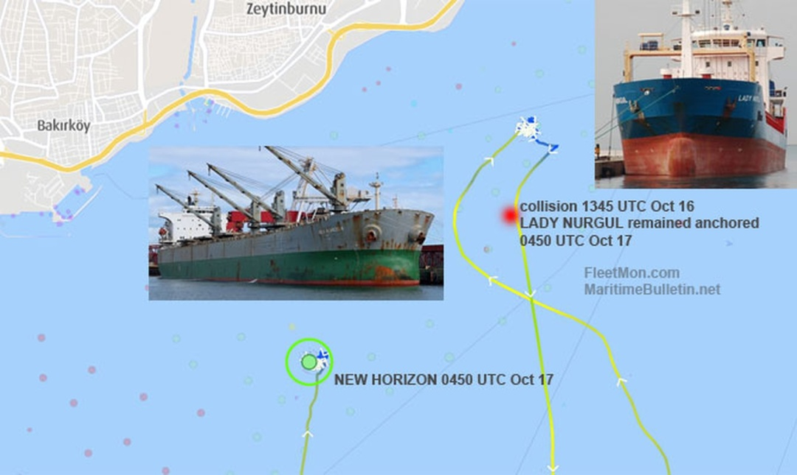In the Sea of Marmara near Istanbul, the bulk carrier NEW HORIZON, which was en route to Odessa for agricultural products, collided with a cargo ship. As Ukrinform reports, this was reported by the trade publication FleetMon. "The bulk carrier NEW HORIZON collided with the cargo ship LADY NURGUL off Ahirkapi, Istanbul, Sea of Marmara, at approximately 13:45 UTC on 16 October," the release said. It notes that the NEW HORIZON was heading from Anchorage to the Black Sea - to Ukraine - to load grain. After the collision, the bulker anchored. The LADY NURGUL, which arrived from Poti, Georgia, remained at anchor after the collision, but is due to continue its voyage to Italy. It is also reported that it is not known how badly the vessels were damaged in the collision. As reported, on 17 October, five ships carrying Ukrainian agricultural products left ports in the Odessa Sea via the "grain corridor" for countries in Africa, Asia and Europe. According to the Ministry of Infrastructure, since the beginning of the implementation of the "grain initiative", 350 ships with 7.8 million tons of agricultural products have left the ports of Greater Odessa.
Source: https://www.blackseanews.net/read/195637

Russians transfer military equipment across the Kerch Strait, there's a ferry queue

The Russians are trying to ferry military equipment across the Kerch Strait, which is one of the reasons for the huge queues across it. In an interview with Ukrinform, the Ukrainian president's deputy permanent representative to the ARC Denis Chistikov said about this. "Everyone already knows what the queues are for crossing the Kerch Strait. And they are forming mainly because the ferries are primarily carrying Russian military equipment. I mean, as soon as the military equipment arrives from the Russian side, the whole queue stops and waits. This causes discontent among truck drivers and the local population. And if the Russians don't set up the movement of the echelons on the railway, the queues at the crossing will be even longer," Chistikov said. He added that because of the problems at the crossing, Mintrans of Crimea recommends using the so-called overland route through the newly occupied territories of the Herson and Zaporizhia regions. However, according to Chistikov, Crimeans are afraid to drive on these roads. "The occupiers assure us that this route is safe, but we fully understand that there is a line of contact nearby, hostilities are taking place, so no one can guarantee safety," he said. Chistikov said the invaders obviously wanted to advertise this route and therefore publicly announced that "70 trucks in an organised group left from the port of Kerch for the newly occupied territories". "Probably they will demonstratively accompany the first column and it will somehow get through, and then everything will be left to its own devices and it will be hard to control whether this route works", - believes the deputy permanent representative of the President of Ukraine in the ARC. According to reports, more than 800 trucks were queuing at the crossing over the Kerch Strait. The Russian Federation has announced that it plans to restore the destroyed elements of the Kerch bridge by 1 July 2023.
Source: https://www.blackseanews.net/read/195624

Change at the helm of the Fleet
Rear Admiral Valentin Iacoblev handed over the command of the Fleet to Rear Admiral Cornel-Eugen Cojocaru, during a ceremony held on Monday 17 October in the military port of Constanta, in the presence of the Chief of Naval Staff, Rear Admiral Mihai Panait.
After the presentation of the order of the Minister of National Defence, the Chief of the Naval Staff handed over the battle flag of the Fleet to the new commander, Rear Admiral Cornel-Eugen Cojocaru. The whole activity took place in the presence of the commanders of units and large units of the Naval Forces, representatives of the central structures of the MFA, former chiefs of the Naval Forces General Staff and of the Fleet Command, as well as representatives of local authorities.
Source: https://www.navy.ro/comunicat.php?id=652

